Agile methodology
Agile methodology is a project management framework that breaks projects down into several dynamic phases, commonly known as sprints.
The Agile framework is an iterative methodology. After every sprint, teams reflect and look back to see if there was anything that could be improved so they can adjust their strategy for the next sprint.

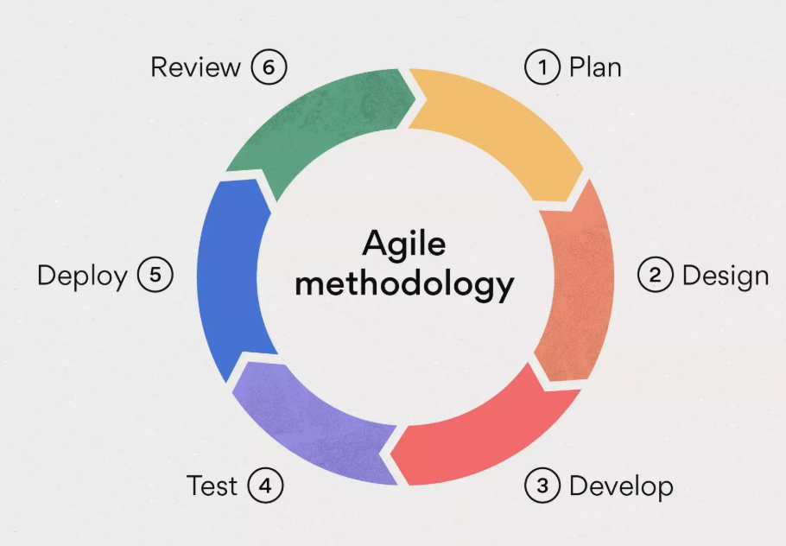
The 4 pillars of Agile
As outlined in the Agile Manifesto, there are four main values of Agile project management:
- Individuals over processes and tools. Agile teams value team collaboration and teamwork over working independently and doing things "by the book.”
- Working software over comprehensive documentation. The software that Agile teams develop should work. Additional work, like documentation, is not as important as developing good software.
- Customer collaboration over contract negotiation. Customers are extremely important within the Agile methodology. Agile teams allow customers to guide where the software should go. Therefore, customer collaboration is more important than the finer details of contract negotiation.
- Responding to change over following a plan. One of the major benefits of Agile project management is that it allows teams to be flexible. This framework allows for teams to quickly shift strategies and workflows without derailing an entire project.

The 12 Agile principles
If the four values of the Agile model are the weight-bearing pillars of a house, then the 12 Agile principles are the rooms you can build within that house. These principles can be easily adapted to fit the needs of your software development process.
The 12 principles used in Agile methodology are:
- Satisfy customers through early, continuous improvement and delivery.When customers receive new updates regularly, they're more likely to see the changes they want within the product. This leads to happier, more satisfied customers—and more recurring revenue.
- Welcome changing requirements, even late in the project. The Agile framework is all about adaptability. In iterative approaches like Agile, being inflexible causes more harm than good.
- Deliver value frequently. Similar to principle #1, continuous delivery of value to your customers or stakeholders frequently makes it less likely for them to churn.
- Break the silos of your projects. Cross-functional teams and collaboration is a key Agile value. The goal is for people to break out of their individual projects and collaborate more frequently.
- Build projects around motivated individuals. Agile management works best when teams are committed and actively working to achieve a goal.
- The most effective way to communicate is face-to-face. If you’re working on a distributed team, spend time communicating in ways that involve face-to-face communication like Zoom calls or daily stand-up meetings.
- Working software is the primary measure of progress. The ultimate goal of software development projects is a working product, and the Agile framework supports this by prioritizing functional software above all.
- Maintain a sustainable working pace. Some aspects of Agile project management can be fast-paced, but it shouldn't be so fast that team members burn out. The goal is to maintain sustainability throughout the development process.
- Continuous excellence enhances agility. If the team develops excellent code in one sprint, they can continue to build off of it the next. Continually creating great work allows teams to move faster in the future.
- Simplicity is essential. Sometimes the simplest solution is the best solution. Agile development aims to not overcomplicate things and find simple answers to complex problems.
- Self-organizing teams generate the most value. Similar to principle #5, proactive teams become valuable assets to the company as they strive to deliver continuous improvement.
- Regularly reflect and adjust your way of work to improve effectiveness. Retrospective meetings are a common Agile practice. It's a dedicated time for Agile teams to look back and reflect on their performance and adapt their behaviors for the future.

Benefits of Agile Methodology
The incorporation of Agile development in software engineering has the following advantages:
- Using Agile software development methodology, people and interactions are preferred over tools and processes.
- It leads to a regular focus on improved design and technical excellence.
- The Agile development process assists in improvement by allowing immediate feedback.
- Fastens the software development process, thus increasing customer trust.
- Allows quick adaptability to meet the change in requirements.
- Incorporates flexibility and adaptability.
- Enhances quality and reliability through a focus on quality assurance and continuous improvement.
- Increase team confidence and allow the set up of a collaborative, positive, and supportive workplace culture.
Disadvantages of Agile Methodology
The disadvantages of the Agile software development process are listed as follows:
- Agile development is linked with lesser documentation and a higher focus on codes.
- Agile software development depends on continuous iteration and customer feedback, leading to difficult timelines, outcomes, and project budget estimation.
- Understanding the quantity and intensity of effort required for project completion is challenging early in the Agile software development lifecycle.
- Dependency on the customer leads to wrong progress in the project if the team encounters ambiguity.
- It is difficult for new programmers to adapt to the workplace environment as the senior programmers make most decisions.
- Higher flexibility and adaptability can also lead to scope creep and lack of control over project scope.
- The swiftness of Agile development with high intensity, more sprints, and close deadlines leads to mental exhaustion and increased pressure on team members, leading to burnout.
- Agile development lacks the structure compared to other methodologies, which results in oversight and poor governance.

